United States History I
Ms. J. Stein/Ms. J. Otiniano/Ms. C. Whitney

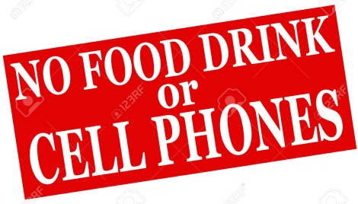
Goal: Students will understand and analyze the political, social, economic, demographic, geographic and cultural issues in US History from the Age of Exploration through Reconstruction using a variety of modalities.

Materials:
- The Americans text
- links on my webpage (part of district website)
- Daily: loose-leaf paper, pencil, red pen, blue/black pen, variety of highlighters
- In locker: ruler, colored pencils, tape, thin black marker (any dark color)

Student Responsibilities:
- EXHIBIT KINDNESS, SELF-MOTIVATION, AND INTEGRITY!!!!!!!
- CHECK THE WEBSITE DAILY!!!!!!!!!!!!!!!!!!!!!!!!!!!!!!!!!!!!!!!!!!!!!!!!
- ALL ELECTRONICS IN “CELL PHONE MOTEL” RESTING!
- E-mail me with questions
- Complete all work on time (make sure your computer & printer are working)
- Come to class prepared; contribute to the class discussion
- Dismissal from a seat; push in your chair
- When absent, student is responsible for homework posted on website
- Have at least one “study buddy” to connect with, especially if absent
- Work is due the day back from an absence
- Work is due BEFORE leaving for a field trip/appointment/sport etc.

Evaluation:
- Point system
- Essays, DBQs, tests, presentations, collaborative work, projects
- Extra credit opportunities
----------------------------cut here--------------------------
I have read the syllabus and discussed it with my child.

Student Name____________________________ Date______________

Parent/Guardian Name________________________________

Parent/Guardian Signature_____________________________

